Lesson 2 - Guess the Number

***What we gonna learn?***

* Importing library (random)
* Variable declaration
* Assignment & Comparison Operators
* User input
* Control Flow (If, elif, else)

Before we start let open the Visual Studio Code and Search & Install “Kite” at the Extension:Marketplace

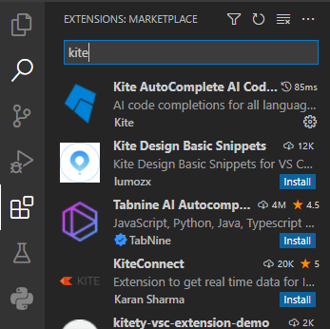

Then search for “Python” and install it

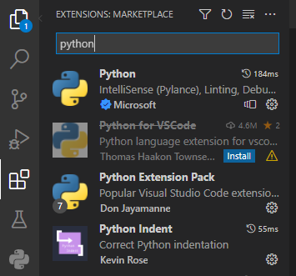

Now let’s start coding!!!

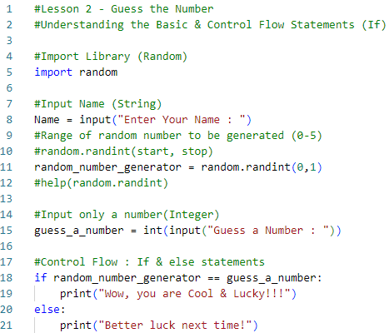

Expected Output :





Code Explanation :

1. Comments are written with # at the front (Line 1,2,4,7,9,10,12,14,17)
2. Line 5 – to import random library (python built in library)
3. Line 8 – Requesting user to input name (the datatype will be string by default)
4. Line 11 – Here is where we use the random library. Other than random.randint(a,b) ,(*a is the lower limit, b is the upper limit, and both will be included in the number generated*) there are more to it. For details [Python Random Module (w3schools.com)](https://www.w3schools.com/python/module_random.asp)
5. Line 15 - Requesting user to guess number in the form of integer
6. Line 18 to 21 – If *guess_a_number* is the same as *randorm_number_generator* (It will enter output line 19, else line 21 will be outputted)

Let’s try….

1. Line 11, Change the value of lower limit and upper limit to 0,10 and try to guess the number. (*Tips : It will be harder to guess since (0,1,2,3,4,5,6,7,8,9,10) will be included*)
2. Line 11, Now we need to change the lower limit and upper limit for random integer manually inside the code, what if we want to request the user to input both the lower limit and upper limit? (*Tips : Create two variable to request for the user input for both lower limit and upper limit, then replace a,b with the variables just created*)
3. Line 15, Since the player do not know what is the lower limit & upper limit, they might enter value that is out of range, can you provide them with instructions to “enter number range from “a” to “b” only”? (*Tips : print(“enter number range from a to b only”*)

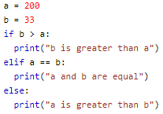

Output : 

1. Line 18, Based on the example above, try to create if,elif statement to update the player if the number is greater, equal or smaller than ***random_number_generated***

Things to ponder…..

1. What if user entered ***integer*** for name? Will there be any error?
2. What if user entered ***non-integer*** for number to guess? Will there be any error? What is the error?
3. For line 15, if we do not put “int” in the code, what will the datatype for guess_a_number be?

